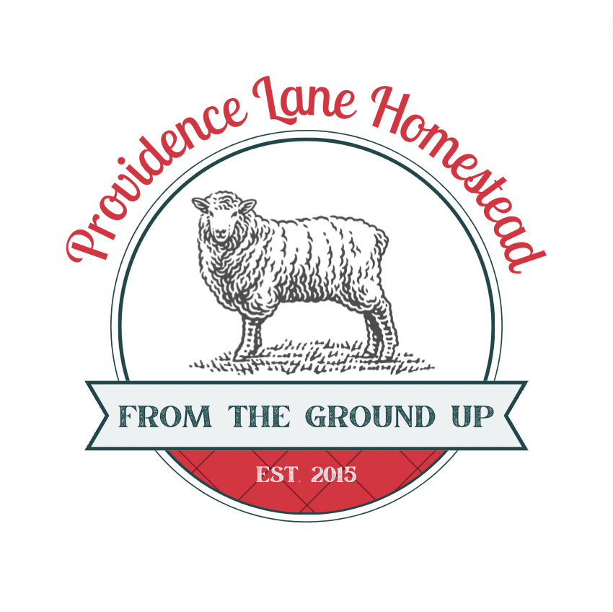
RAM & WETHER SAFE FEED GUIDE
Preventing Urinary Stones in Heritage Sheep
Providence Lane Homestead – Border Leicester Conservation Program

The advice below is based on my own experience feeding my flock of Border Leicester sheep. Some of this has been earned the hard way. It is not meant to replace the information or guidance a trained small ruminant nutritionist and/or your veterinarian can provide.

1. Why Nutrition Matters for Males
Rams and wethers (castrated males) have very narrow plumbing: a tiny tube at the end of the penis called the urethral process and a tight S-shaped bend called the sigmoid flexure

If minerals begin to crystallize in the urine, these are the first places that get blocked.

When it comes to avoiding urinary stones, diet is one of the best and most achievable variables we can control.

2. The Chemistry (Explained Simply)
Urinary stones form when minerals in the feed exceed what the body can safely dissolve in urine.

There are two major mineral culprits:
A. Calcium (Ca)
- Very high in alfalfa, clover, and many rich legume hays.
- Too much calcium leads to calcium carbonate stones.
These are:
- very hard
- round
- almost impossible for the animal to pass
- not dissolvable with medication
B. Phosphorus (P)
- Very high in grain — barley, oats, corn.
- Too much phosphorus leads to struvite stones.
These form when:
- phosphorus is high
- urine is alkaline (pH too high)

The Ca:P Ratio
The calcium-to-phosphorus ratio is critical.
Safe target:
Between 1.5:1 and 2:1 (slightly more Ca than P)

Danger zones:
Alfalfa alone: Ca:P can be 5:1 or even 8:1
Grain-heavy diet: Ca:P can flip to 1:3 or 1:4
Feed testing tells you the actual Ca and P in your hay so you can correct the ratio safely.

3. What Causes Stones (Practical List)
When urine becomes too alkaline (the pH is too high), this imbalance can cause the formation of stones. Different minerals can contribute to different kinds of urinary stones. Too much phosphorus, particularly from grain-heavy diets, can encourage phosphatic stones. Calcium-rich feeds can contribute to calcium-based stones under certain conditions. The important thing is to balance the entire ration, not simply add one feed to compensate for another.
HIGHER RISK
- Alfalfa or clover hay fed to rams/wethers
- Barley, oats, or corn
- Pelleted grower rations
- Inadequate salt
- No ammonium chloride
- Hard water or low water intake
- Sudden ration changes
- Overconditioning / fat deposition

LOWER RISK
- Mixed-grass hay
- Tested hay with known Ca:P
- Mineral balanced to your forage
- Salt always available
- Ammonium chloride access
- Plenty of fresh water
- Slow, steady growth

4. Why Heritage Breeds Need Forage-Based Feeding
Heritage breeds like Border Leicesters developed in low-input, forage-dominant systems for hundreds of years.

Modern commercial breeds are often selected for rapid growth or lots of lambs (reproductive output). Heritage breeds have different breeding histories and may have different nutritional needs. Feeding programs should reflect the animals themselves, not simply the system they came from.

Heritage breeds are optimized for:
- slow and steady growth
- grass-based diets
Putting a heritage ram on a high-calcium + high-phosphorus, fast-growth ration (alfalfa + barley) is a mismatched system — like feeding a pony a racehorse diet.

5. Feeding Recommendations for Rams and Wethers
A. Forage (Hay)
Best:
- Mixed-grass hay
- Timothy, brome, fescue, orchardgrass mixtures
Avoid:
- Alfalfa
- Clover-dominant hay
If you must feed alfalfa, have the forage tested and ask your nutritionist to balance the complete ration.

B. Grain
Rams and wethers should not receive grain.
- No barley.
- No oats.
- No pellets formulated for lamb finishing.
Grain increases urine phosphorus → increases struvite stones.

C. Minerals
Use a balanced sheep-safe loose mineral that complements your forage and keeps Ca:P near 2:1 in the complete ration, not just the mineral supplement. Nutritionists are often available through feed mills or ask your veterinarian for a referral.

D. Salt
Free-choice loose salt encourages drinking, which dilutes urine.
This alone drops stone risk substantially.

E. Ammonium Chloride
Ammonium chloride can help prevent certain types of urinary stones by making urine more acidic. Ask your veterinarian or nutritionist whether your ram/wether needs it and how much to provide. A block alone may not supply an effective amount.

F. Water
Urine must stay dilute.
Provide:
- clean water
- warm water in winter
- multiple sources if possible
Anything that reduces drinking increases risk.

6. Signs of Trouble
Immediate veterinary attention is required if a ram/wether:
- strains to urinate
- dribbles urine
- shows crystals or sand on prepuce
- kicks at belly
- vocalizes distress
- stops eating
A urinary blockage is a veterinary emergency. If you suspect one, call your veterinarian immediately. Do not wait to see whether it resolves on its own.
7. Summary (Short Version for Buyers)
SAFER
- Mixed-grass hay
- Loose salt
- Balanced mineral for your forage
- Ammonium chloride block if recommended by your care professionals
- Plenty of water
- No grain, especially for mature males
RISKIER
- Alfalfa-heavy rations without appropriate mineral balance
- Barley, oats, corn
- Lamb grower pellets
- Sweet feed
- Rations formulated for commercial feedlot lambs

8. Why Feed Tests Matter
Hay is not consistent. Two bales from the same field can have different Ca:P ratios.
A feed test tells you:
- actual calcium
- actual phosphorus
- protein
- energy
- minerals
- whether your hay matches your mineral
Without a feed test, you are managing blind.
With it, urinary health management becomes much more straightforward.

Good feeding isn't necessarily complicated, but it does require a little homework. Know what you're feeding, understand what your sheep actually need, and don't assume that more is always better. A good forage-based diet, balanced minerals, plenty of clean water and a watchful eye will go a long way toward keeping your boys healthy. These lovely old breeds have been entrusted to our care, and with that comes a responsibility to give them the best chance at long, comfortable lives. A little attention to what's going into the front end can save an awful lot of trouble at the other.

